**Thread Group Plugin**

**Adding thread group plugin**

* Go to any browser and type JMeter plugins manager.
* Click on the link https://jmeter-plugins.org.
* Now, once you click on **Install**, you will get a jar file that will install the plugins.

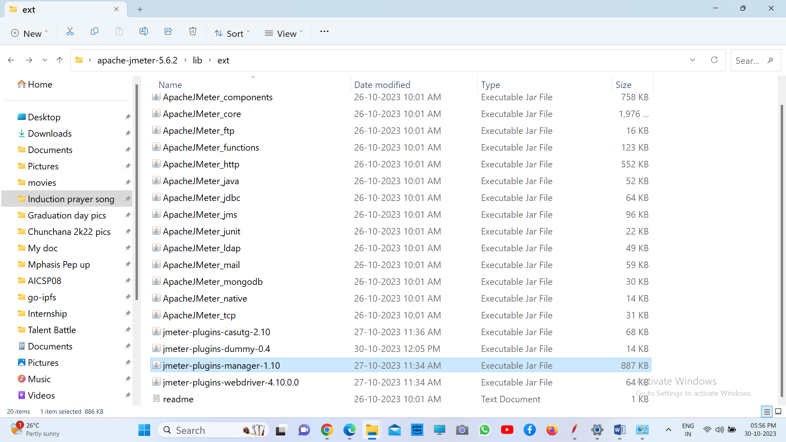

**Adding a specific thread group plugin**

* + Open the JMeter tool.
  + Click on the **Options** tab and then click on Plugins Manager.
  + Search for the custom thread group plugin and check the box next to it.
  + Finally, click on **Install** and restart the JMeter tool.